DATAVISION IMAGE LLC
906 Via De Angeles
San Clemente, CA 92672
info@datavisionimage.com

Technical Instructions for using the DATAVISION Corporate Encryption API

Contents of the DLL
The Corporate Encryption DLL has three commands:
GetPassword(ByVal MyPasswordIn As String) As String
EncryptString(ByVal MyString As String) As String
DeEncryptString(ByVal MyString As String) As String

Discussion
Corporate Encryption is a Windows API that can easily be added to any Windows program including Visual Studio programs such as VB.Net, C#.Net, ASP.NET to allow the program to internally encrypt and decrypt data with a single, simple command.
Sensitive data such as connection strings, passwords, sensitive parameters, lists, etc. can be internally encrypted and therefore will be unavailable to anyone trying to hack or use parts of the program to gain access to lists, connections string, and so forth.
The Windows API has three commands that can be interactively used by the programmer to protect exposed data.
The Windows API can also be used to construct encryption programs that can only be deciphered by a recipient of the Windows API along with the password used for encryption. This practice is referred to as salted password protection. While widely used in angular JS type encryption, the use in Windows programs is more complex. This Windows API greatly simplifies the process.

The kit contains the following items:
Encrypt Two DLL
Install program for test demo program
Source code for test demo program
Programmer instructions for deploying and using the DLL

Here are the results of the test program
At Start:
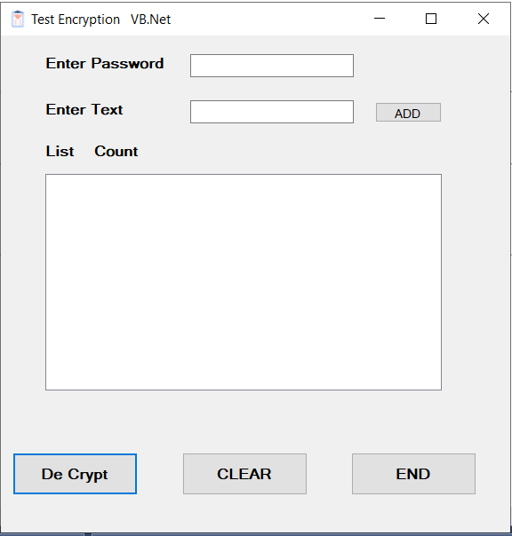

Failure to enter a password will result in an error:
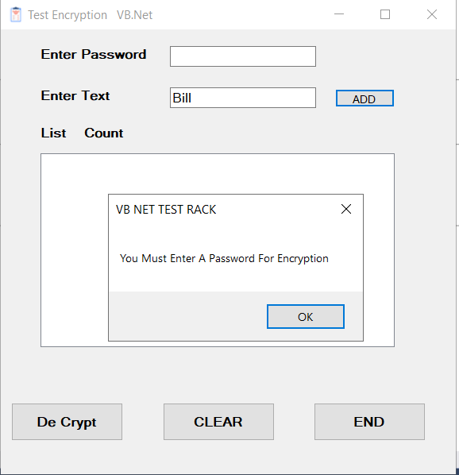
When a string is entered the ADD button encrypts it so the screen looks like this:
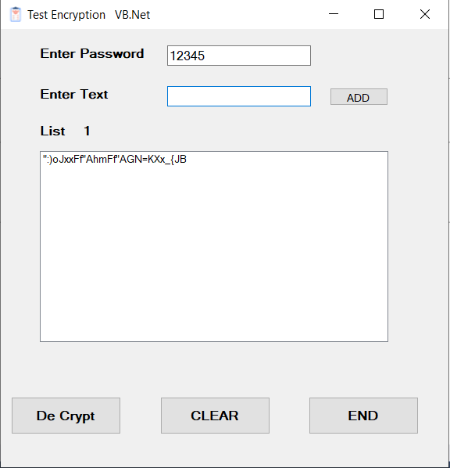
The code to encrypt is very simple. Notice how the password is passed at the start of the program and when the Decrypt command is called.
MyPassword = Trim(txtPassword.Text)

If Trim(txtPassword.Text) = "" Then
MsgBox("You Must Enter A Password For Encryption")
txtPassword.Focus()
Exit Sub

End If
MyPassword = MyEncryption.GetPassword(MyPassword)

TextToAdd = txtEnterText.Text

EncryptedText = MyEncryption.EncryptString(TextToAdd, MyPassword)
Notice the warning message is generated by the application. The DLL will return the phrase “PASSWORD REQUIRED” instead of the encrypted text if the password is missing.
The application allows you to add items to the list
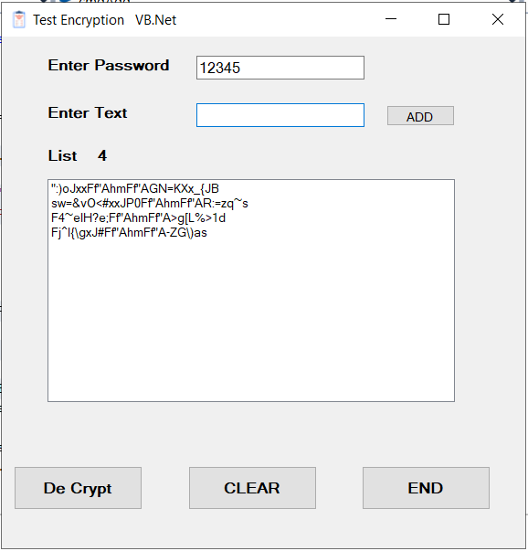
Press the Decrypt button to get the clear text. Here is the code used by the Decrypt button
MyPassword = Trim(txtPassword.Text)

If Trim(txtPassword.Text) = "" Then
MsgBox("You Must Enter A Password For Encryption")
txtPassword.Focus()
Exit Sub

End If
MyPassword = MyEncryption.GetPassword(MyPassword)
For I = 0 To (MyCounter) - 1
TextToDecrypt = lstNames.Items(I)
MyDecryptedText = MyEncryption.DeEncryptString(TextToDecrypt, MyPassword)

lstNames.Items.Add(MyDecryptedText)
Next
Notice the warning is given by the application program. The DLL will return this screen if the password is missing or incorrect:

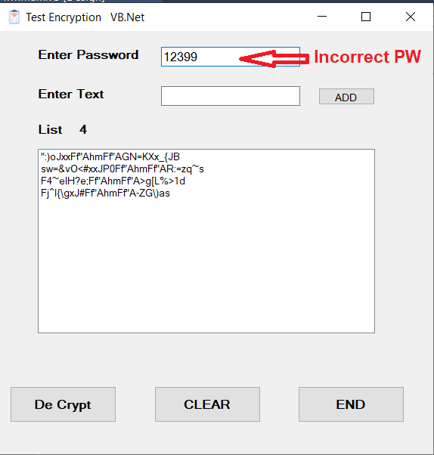

This will result in the following:
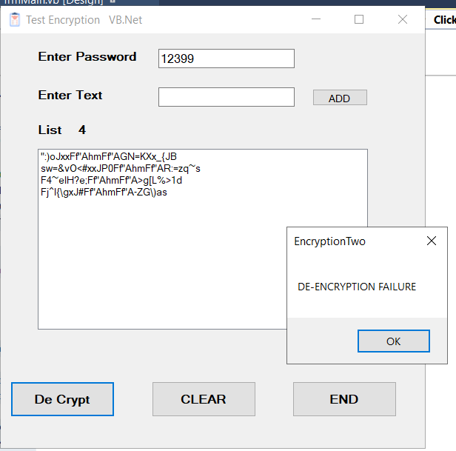
This message is produced by the DLL and will repeat for each line with an incorrect password
If the correct password is used the encrypted text is replaced by clear text
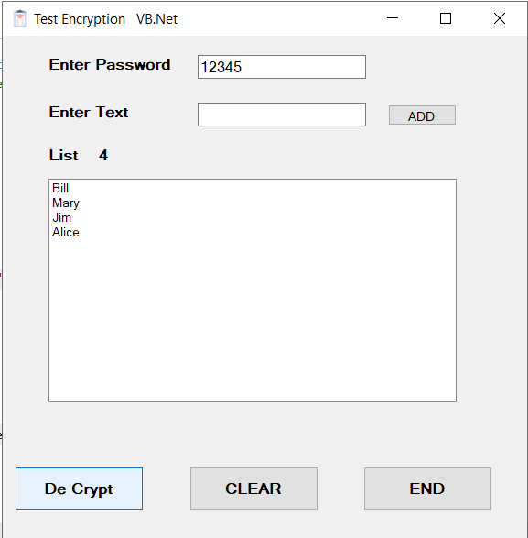

Using these simple commands, the programmer can easily protect connection strings, lists, passwords and so forth with only a line or two of code.

Source Code:
Public Class frmMain
Public MyEncryption As New EncryptionTwo.EncryptTextTwo
'this is how to instantiate the DLL

Dim MyPassword As String
Private Sub cmdEnd_Click(sender As Object, e As EventArgs) Handles cmdEnd.Click
End
End Sub

Private Sub frmMain_Load(sender As Object, e As EventArgs) Handles Me.Load
lstNames.Items.Clear()
End Sub

Private Sub cmdAdd_Click(sender As Object, e As EventArgs) Handles cmdAdd.Click
'this sub adds strings to the list box and encrypts them as you go
Dim TextToAdd As String = ""
Dim EncryptedText As String = ""
Dim NumberOfItems As Integer = 0

MyPassword = Trim(txtPassword.Text)

If Trim(txtPassword.Text) = "" Then
MsgBox("You Must Enter A Password For Encryption")
txtPassword.Focus()
Exit Sub

End If
MyPassword = MyEncryption.GetPassword(MyPassword)

TextToAdd = txtEnterText.Text

EncryptedText = MyEncryption.EncryptString(TextToAdd, MyPassword)
lstNames.Items.Add(EncryptedText)
txtEnterText.Text = ""
NumberOfItems = lstNames.Items.Count
lblCount.Text = NumberOfItems.ToString
txtEnterText.Focus()
End Sub

Private Sub cmdClear_Click(sender As Object, e As EventArgs) Handles cmdClear.Click
'clears the data
txtEnterText.Text = ""
lstNames.Items.Clear()
lblCount.Text = (lstNames.Items.Count).ToString
End Sub

Private Sub txtPassword_LostFocus(sender As Object, e As EventArgs) Handles txtPassword.LostFocus
'this sub check that a password has been entered
If Trim(txtPassword.Text) = "" Then
MsgBox("You Must Enter A Password For Encryption")
txtPassword.Focus()
Exit Sub

End If
End Sub
Private Sub cmdDeCrypt_Click(sender As Object, e As EventArgs) Handles cmdDeCrypt.Click
'this sub decrypts the strings in the list box and replaces the encrypted text with clear text
Dim MyDecryptedText As String = ""
Dim TextToDecrypt As String = ""
'lstNames.Items.Add("")
'lstNames.Items.Add("TRANSLATED VALUES")
Dim MyCounter As Integer = lstNames.Items.Count
Dim ClearCounter As Integer = 0
For I = 0 To (MyCounter) - 1
TextToDecrypt = lstNames.Items(I)
MyDecryptedText = MyEncryption.DeEncryptString(TextToDecrypt, MyPassword)

lstNames.Items.Add(MyDecryptedText)
ClearCounter = ClearCounter + 1
Next
For i = ClearCounter - 1 To 0 Step -1

lstNames.Items.RemoveAt(i)

Next

lstNames.Refresh()

End Sub
End Class

