Code Lock Installation Package
Thank you for purchasing our CodeLock API. This API can be easily added to your Windows software program to ensure your program(s) are not copied illegally. Each time your program is installed, the CodeLock DLL will require a unique License Code to be entered. The License Code generation is included in the CodeLock package.

Kit includes

- DLL which will require a unique License Key to be entered upon any installation of your software
- License Key generation application
- .Net source code for license generation
- Sample program showing how to use DLL with Source code and Install program
- List of commands with explanation
The CodeLock DLL is so simple to use.
- First, in a .Net application specify a reference for the DLL
- Add these lines of code
Public Class frmTestCodeLock
Public MyCodeLock As New CodeLock.Class1
(This instantiates the DLL)

Private MyCompanyName As String = "DATAVISION IMAGE LLC info@datavisionimage.com"
(This passes your company name to the DLL for messages generated)

- Add these lines to your code at start up:

Private Sub frmTestCodeLock_Load(sender As Object, e As EventArgs) Handles Me.Load
MyCodeLock.AddMessage(MyCompanyName)
Dim MyResult As String = ""
MyResult = MyCodeLock.CheckSerialNumber()
If Trim(MyResult) = "INVALID" Then
MsgBox("License Code Is Incorrect. Please Contact " + vbCrLf + MyCompanyName + vbCrLf + vbCrLf + "THIS PROGRAM WILL END")
End
End If
End Sub
Once the program has these additions, it will require a unique license code to generate the License. The functions to generate a License code are contained within the DLL. To prevent someone from stealing the DLL and using it to generate the license code, the function to generate the License code is password protected. You will receive the password in a separate email.
The DLL will allow you to reset the License Key with this command:
Private Sub frmTestCodeLock_Load(sender As Object, e As EventArgs) Handles Me.Load
MyCodeLock.ResetSerialNumber()
Exit Sub
End Sub
The CodeLock package includes a program to generate the License Code. This is what the License code generator program looks like: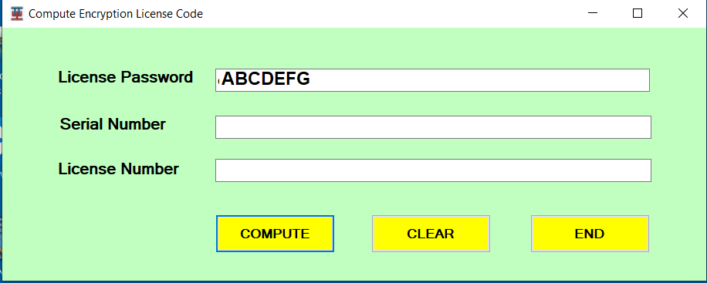

Code Lock has 4 commands:
AddMessage (Company name as string)
CheckSerialNumber() as string
Compute License Code(SerialNumber as string, Password as string) as string
Reset Serial Number()

Detailed explanation:
MyCodeLock.AddMessage(MyCompanyName)
Use this command to add your company name and a contact email address
Example:
Private MyCompanyName As String = "DATAVISION IMAGE LLC info@datavisionimage.com"
MyCodeLock.AddMessage(MyCompanyName)

CheckSerialNumber() as string
Use this command to see if the program Serial Number and License number are legitimate. If the License number is correct the function will return “VALID”. If not, the function will return “INVALID”.
Example:
MyResult = MyCodeLock.CheckSerialNumber()
If Trim(MyResult) = "INVALID" Then
MsgBox("License Code Is Incorrect. Please Contact " + vbCrLf + MyCompanyName + vbCrLf + vbCrLf + "THIS PROGRAM WILL END")
End
End If

Compute License Code(SerialNumber as string, Password as string) as string
Use this command to generate a license number for a given serial number. Note that a password is required to use this function.
Example:
Private Sub cmdCompute_Click(sender As Object, e As EventArgs) Handles cmdCompute.Click
txtLicenseCode.Text = MyCodeLock.ComputeLicenseCode(txtSerialNumber.Text, txtLicensePassword.Text)
End Sub

Reset Serial Number()
Use this command to reset the serial number for a program. Only used in rare occasions if an error has occurred.
Example:
Private Sub frmTestCodeLock_Load(sender As Object, e As EventArgs) Handles Me.Load
MyCodeLock.ResetSerialNumber()
Exit Sub
End Sub

